### **Lecture: Security Issues Related to Social Media – Part 1**

**Objective:**This lecture will help students understand the common security threats on social media, the techniques used by attackers, and real-life case studies of security breaches on social platforms.

### **1: Introduction to Social Media Security**

* **Social Media’s Impact**:  
  Social media platforms like Facebook, Instagram, Twitter, and Snapchat have become essential parts of daily life. They allow people to share information, stay connected, and express themselves.  
  **However**, with such widespread use, there are growing risks associated with privacy and security. Social media platforms collect large amounts of personal data, making them attractive targets for hackers.

### **2: Common Security Threats on Social Media**

1. **Phishing**:  
   Phishing is when attackers trick users into giving up personal information like passwords or credit card numbers by pretending to be a trusted source (e.g., a fake Facebook login page).
   * **Example**: A user receives a direct message that looks like it’s from Instagram, asking them to log in to view a private message. The link takes them to a fake login page, and the attacker captures the credentials.
2. **Social Engineering**:  
   This involves manipulating people into giving up confidential information, often through personal interactions or misleading content.
   * **Example**: An attacker might pretend to be a friend asking for help and ask for sensitive information or money.
3. **Malware**:  
   Attackers spread malware (e.g., viruses, spyware, or ransomware) through social media platforms by sharing infected links or attachments. Once the user clicks the link or downloads a file, their device gets infected.
   * **Example**: A Facebook post promises free movie tickets, but clicking the link installs malware on the user’s computer.
4. **Fake Profiles**:  
   Attackers create fake profiles to impersonate other people or companies to scam users or collect their personal data.
   * **Example**: A fake celebrity account might message users, promising them rewards if they share their credit card information.
5. **Identity Theft**:  
   Attackers gather enough personal information from social media profiles to steal a person’s identity and perform fraudulent activities.
   * **Example**: A person’s full name, date of birth, and photos are available on Facebook. An attacker uses this information to open a bank account under their name.

### **3: Techniques Used by Attackers**

1. [**Password Guessing and Credential Stuffing**](https://www.youtube.com/shorts/Ej-kCEK7-Oo):  
   Attackers try common passwords (e.g., "password123") or use lists of stolen passwords from other breaches to gain access to social media accounts.
   * **Prevention Tip**: Use strong, unique passwords and enable two-factor authentication (2FA).
2. **Link Spoofing**:  
   Attackers create URLs that look legitimate but redirect users to malicious websites. These are often shared in messages or posts.
   * **Prevention Tip**: Always check URLs before clicking. Hover over the link to see where it leads.
3. **Cross-Site Scripting (XSS)**:  
   Attackers inject malicious code into social media websites, allowing them to steal session cookies or sensitive data.
   * **Prevention Tip**: Keep browsers up to date and avoid interacting with suspicious content.
4. **Session Hijacking**:  
   Attackers intercept session tokens to gain unauthorized access to user accounts, usually through unsecured public Wi-Fi networks.
   * **Prevention Tip**: Avoid logging into social media on public Wi-Fi without a VPN.

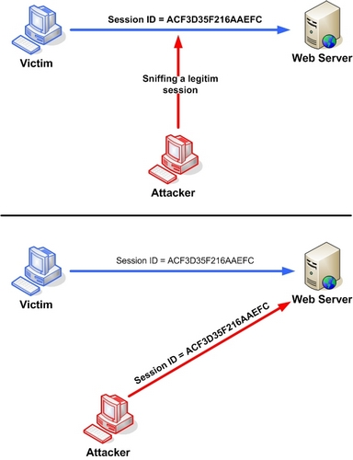

### **4: Case Study 1 – Twitter Hack (2020)**

* **What Happened?**In July 2020, several high-profile Twitter accounts, including those of Elon Musk, Jeff Bezos, and Barack Obama, were hacked as part of a bitcoin scam. Hackers gained control of these accounts and posted messages asking followers to send cryptocurrency to a specific wallet, promising to double their money.
* **How It Was Done**:  
  The attackers used **social engineering techniques** to target Twitter employees. They called and manipulated the employees into giving access to Twitter’s internal tools. This allowed them to take over the accounts and post messages.
* **Impact**:  
  The hackers managed to collect over $120,000 in bitcoin before Twitter shut down the scam. The breach raised significant concerns about the security of social media platforms and the need for better internal safeguards.

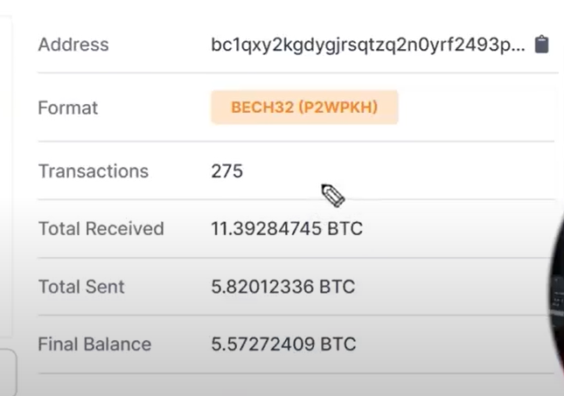

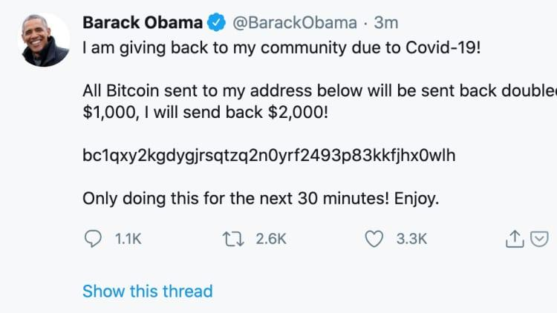

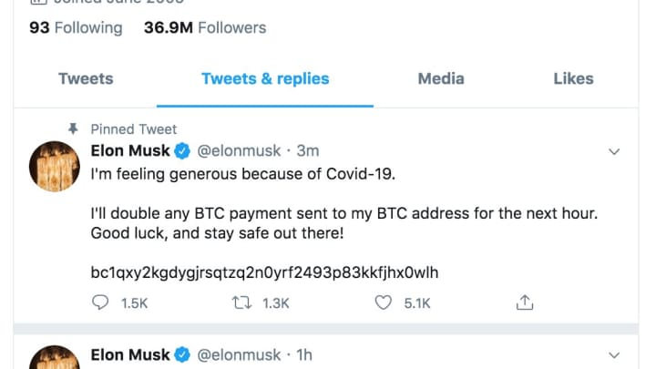

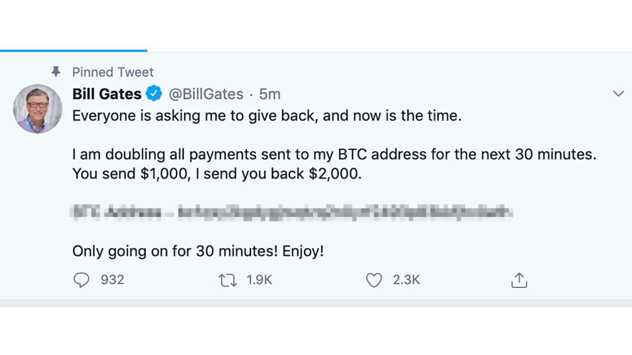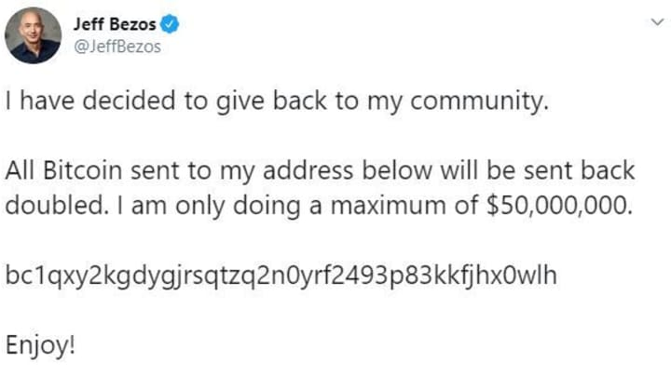

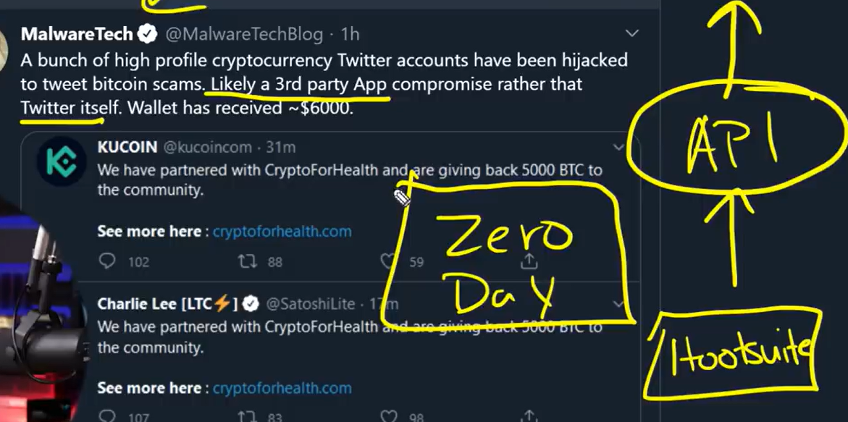

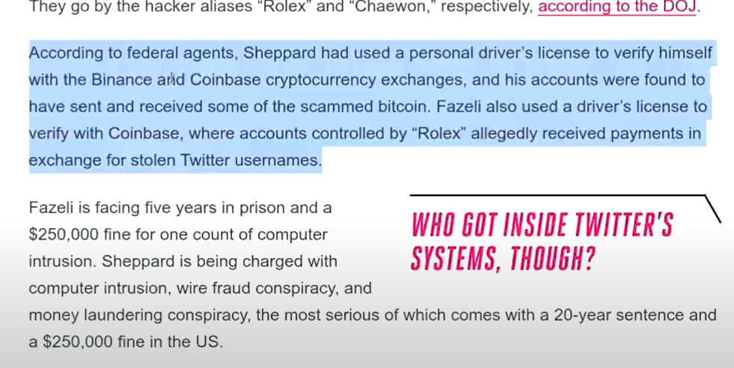

### **5: Case Study 2 – Snapchat Data Breach (2014)**

* **What Happened?**In 2014, attackers used a **phishing scam** to gain access to Snapchat employees’ credentials. Once they had access, they downloaded a database containing the personal information of around 4.6 million users, including usernames and phone numbers.
* **How It Was Done**:  
  Attackers created fake login pages to trick Snapchat employees into entering their credentials, giving the attackers full access to Snapchat’s systems.
* **Impact**:  
  The breach caused a public outcry, as Snapchat was seen as a platform where privacy should be a priority. This incident led Snapchat to improve its security features, including two-factor authentication.

### **6: Best Practices for Social Media Security**

**1. Use Strong, Unique Passwords:**

* Avoid using the same password across multiple platforms. Use a mix of letters, numbers, and symbols.
* **Example**: Don’t use “password123” as your password for Facebook. Use something like “B!keRide2021$”.

**2. Enable Two-Factor Authentication (2FA):**

* This adds an extra layer of security by requiring you to enter a code sent to your phone when logging in.
* **Example**: When you log into Instagram, you receive a code on your phone that you must enter along with your password.

**3. Be Careful of What You Share:**

* Avoid sharing too much personal information publicly, such as your address, phone number, or travel plans.
* **Example**: Instead of posting "Going on vacation for two weeks!", share your trip photos after you return.

**4. Check Privacy Settings Regularly:**

* Review your privacy settings on platforms like Facebook and Instagram to ensure only trusted friends can see your posts.
* **Example**: On Facebook, you can adjust your settings so that only friends (not the public) can see your photos and posts.

**5. Avoid Public Wi-Fi for Sensitive Activities:**

* Don’t log into social media accounts on public Wi-Fi unless you are using a VPN. Hackers can easily intercept your data on unsecured networks.
* **Example**: Wait until you get home to log into your Instagram account instead of using the airport Wi-Fi.

### **7: Future Trends in Social Media Security**

1. **Artificial Intelligence (AI) for Threat Detection**:  
   Social media platforms are increasingly using AI to detect suspicious activity, such as mass account hacking or phishing attempts, before it escalates.
   * **Example**: Facebook uses AI to detect unusual login attempts and alert users when something seems off.
2. **Improved Encryption**:  
   More platforms are expected to use stronger encryption to protect users’ data and communications.
   * **Example**: WhatsApp’s end-to-end encryption ensures that only you and the person you’re messaging can read what’s sent.
3. **Biometric Security Features**:  
   Social media platforms might integrate more biometric security features like facial recognition or fingerprint scanning for account logins.
   * **Example**: Instead of just typing in a password, you might scan your fingerprint to log into Instagram in the future.

### **8: Conclusion**

* Social media security is a crucial issue in today’s connected world. Users must stay informed about the threats and take proactive steps to protect themselves.
* By using strong passwords, enabling two-factor authentication, and being mindful of what they share, individuals can significantly reduce their risk of falling victim to social media attacks.

### **9: Discussion Questions**

1. **What measures can you take to improve your own social media security?**
2. **How do you think social engineering impacts social media security?**
3. **What would you do if your social media account got hacked? What steps would you take?**

### **Lecture: Security Issues Related to Social Media – Part 2**

**Objective:**This lecture will help students understand the importance of flagging and reporting inappropriate content, the legal implications of posting inappropriate material, and best practices for secure social media usage.

### **1: Introduction to Social Media Security – Part 2**

* Social media is a powerful tool that connects billions of people. However, it’s also a platform where inappropriate and harmful content can spread quickly.
* **Objective**: Learn how to identify, flag, and report inappropriate content, understand the legal consequences of posting such material, and follow best practices for staying safe and secure online.

### **2: What Is Inappropriate Content?**

* **Definition**: Inappropriate content refers to any post, image, video, or comment that violates social media platform rules or is harmful to others.  
  **Examples**:
  + **Hate Speech**: Insulting, offensive, or threatening content based on race, gender, religion, or nationality.
  + **Violent Content**: Posts that show or encourage violence, such as fights, assaults, or cruelty.
  + **Sexually Explicit Material**: Content that is sexually suggestive or explicit, including pornography or harassment.
  + **Cyberbullying**: Harassing, threatening, or embarrassing someone online.
  + **Misinformation**: Spreading false information, like fake news or hoaxes.
* **Real-Life Example**:
  + During elections, misinformation can spread quickly. In 2020, platforms like Facebook and Twitter were flooded with false information about voting, causing confusion among users.

### **3: Why Is It Important to Flag and Report Inappropriate Content?**

* **Keeping the Platform Safe**:  
  Flagging inappropriate content helps social media platforms maintain a safe environment. Without users' help, harmful content may go unnoticed for long periods.  
  **Example**: On YouTube, users can report videos that violate community guidelines. If a video gets enough reports, YouTube reviews it and takes it down if necessary.
* **Protecting Vulnerable People**:  
  Inappropriate content, especially hate speech or cyberbullying, can target vulnerable groups like children or minorities. Reporting it helps protect these groups from harm.  
  **Example**: A teen facing cyberbullying on Instagram can report harassing messages to get them removed and potentially have the bully’s account suspended.
* **Preventing Harmful Behavior**:  
  When harmful content, like threats of violence, goes unreported, it can escalate and lead to real-life consequences. Reporting helps prevent such situations.  
  **Example**: In 2018, a user on Twitter posted threats against a school. The threats were reported by users and passed on to the authorities, preventing potential violence.

### **4: How to Flag and Report Inappropriate Content**

* **Step-by-Step Process** (Using Facebook as an example):
  1. Click the three dots next to the post or comment.
  2. Select "Find support or report post."
  3. Choose the reason (e.g., hate speech, harassment).
  4. Submit the report.
* **Other Platforms**:  
  Each social media platform has similar features. Users should familiarize themselves with how to report content on platforms like Instagram, Twitter, and TikTok.

### **5: What Happens After You Report Content?**

1. **Review Process**:  
   Social media companies typically have teams or AI systems that review reported content.
   * **Example**: Facebook uses a combination of human moderators and AI to review reports. Content that violates policies is removed.
2. **Consequences for the Poster**:  
   Depending on the severity of the violation, the content could be removed, the user could be banned temporarily, or the account could be permanently deleted.
   * **Example**: A Twitter user posting threats may have their account suspended after enough reports.
3. **Impact on the Community**:  
   By flagging inappropriate content, users contribute to a safer online community, which encourages more positive and responsible social media behavior.

### **6: Legal Implications of Posting Inappropriate Content**

1. **Hate Speech and Harassment**:  
   Many countries, including India, have strict laws against hate speech and online harassment. Posting such content can lead to fines or jail time.
   * **Example**: In 2021, a person in India was arrested for spreading hate speech on Twitter, violating Indian law on communal harmony.
2. **Sharing Private Information (Doxxing)**:  
   Doxxing refers to sharing someone's private information online without consent. This is illegal in many countries and can lead to legal consequences.
   * **Example**: A person who posts someone’s address or phone number online could face charges for invasion of privacy.
3. **Spreading False Information (Misinformation)**:  
   Posting fake news or misinformation, especially about serious topics like health or elections, can result in legal consequences in some countries.
   * **Example**: During the COVID-19 pandemic, many people were arrested for spreading false information about vaccines or the virus on social media.
4. **Posting Explicit Content**:  
   Sharing sexually explicit content, especially involving minors, is illegal and can lead to severe legal action, including imprisonment.
   * **Example**: A high-profile incident in the US involved someone sharing explicit photos without the other person's consent, which led to criminal charges under "revenge porn" laws.

### **7: Real-Life Case Study 1: The Yahoo Chat Room Incident (1999)**

* **What Happened**:  
  In the early days of the internet, Yahoo chat rooms were popular for online discussions. In 1999, an individual started spreading racist and hateful content in chat rooms, targeting specific racial and ethnic groups.
* **Outcome**:  
  Users reported this behavior to Yahoo, and law enforcement was involved. The individual was banned from Yahoo, and the case highlighted the need for moderation in online spaces.

### **8: Real-Life Case Study 2: The TikTok Incident (2021)**

* **What Happened**:  
  In 2021, a harmful trend spread on TikTok where users were encouraged to destroy school property and post videos of it. This "challenge" led to real-life vandalism in schools.
* **Outcome**:  
  TikTok quickly flagged and removed videos related to this challenge. Several students were arrested for participating, and schools raised awareness about the legal consequences of such behavior.
* **Key Lesson**:  
  Posting or participating in harmful trends on social media can have serious real-world consequences, both legally and personally.

### **9: Best Practices for Secure Social Media Usage**

1. **Think Before You Post**:  
   Always consider the potential consequences of what you're sharing. Once something is posted online, it’s hard to take back.
   * **Example**: A tweet from years ago can resurface and harm someone’s reputation later in life.
2. **Adjust Your Privacy Settings**:  
   Keep personal information private by adjusting settings so that only trusted friends can see your posts.
   * **Example**: On Instagram, switch your account to private so only approved followers can see your content.
3. **Don’t Overshare**:  
   Avoid sharing personal information like your home address, phone number, or vacation plans.
   * **Example**: Instead of posting "Leaving for vacation tomorrow," share your vacation photos after you return.
4. **Be Wary of Third-Party Apps**:  
   Many social media platforms allow third-party apps to access your account. Always review the permissions these apps have and remove any that are unnecessary.
   * **Example**: A quiz app on Facebook might request access to your personal data. Make sure to remove such apps if they are not trustworthy.
5. **Keep Your Passwords Secure**:  
   Use strong, unique passwords for each of your social media accounts, and enable two-factor authentication (2FA) where possible.
   * **Example**: Instead of using "123456" for all your social media accounts, create different strong passwords and store them in a password manager.
6. **Report Suspicious Behavior**:  
   If you notice strange activity on your account (like unknown logins or strange posts), report it immediately to the platform and change your password.
   * **Example**: If you receive a message from a friend on Instagram that seems suspicious, they might have been hacked. Let them know and report it.

### **10: Discussion Questions**

1. **Have you ever seen inappropriate content on social media? How did you react?**
2. **What would you do if someone shared private information about you without your consent?**
3. **Why is it important to review your social media privacy settings regularly?**

### **11: Conclusion**

* Flagging inappropriate content, understanding the legal implications of social media posts, and following best practices are key to maintaining a safe and responsible online presence.
* Always be mindful of what you post, report harmful behavior, and stay updated on how to protect your privacy on social media.